**Laboratory work 2**

**Exercise 1.**

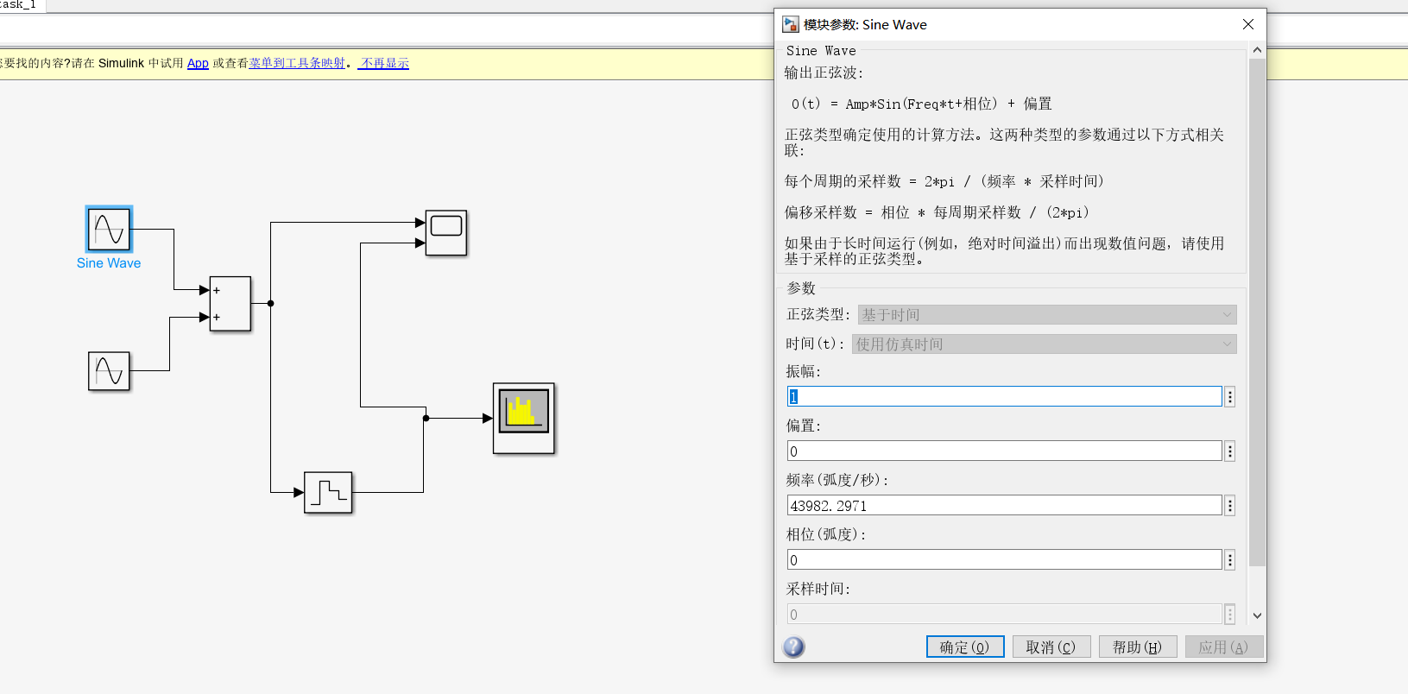

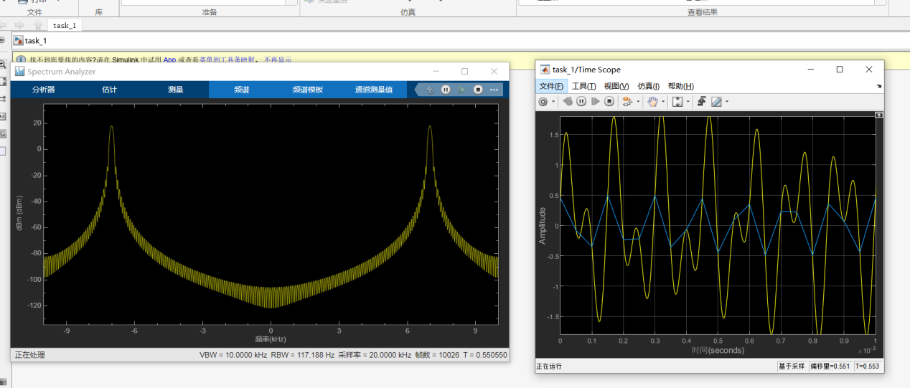

**Exercise 2.**

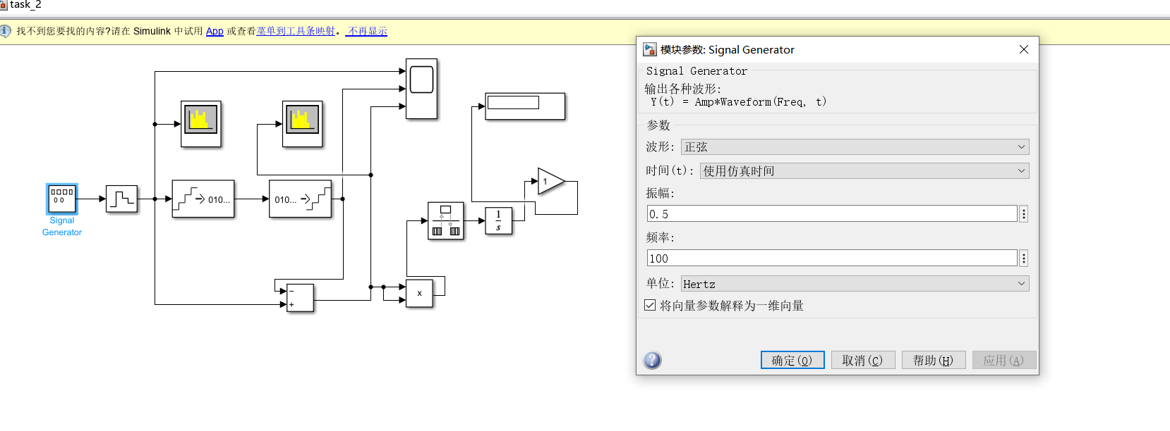

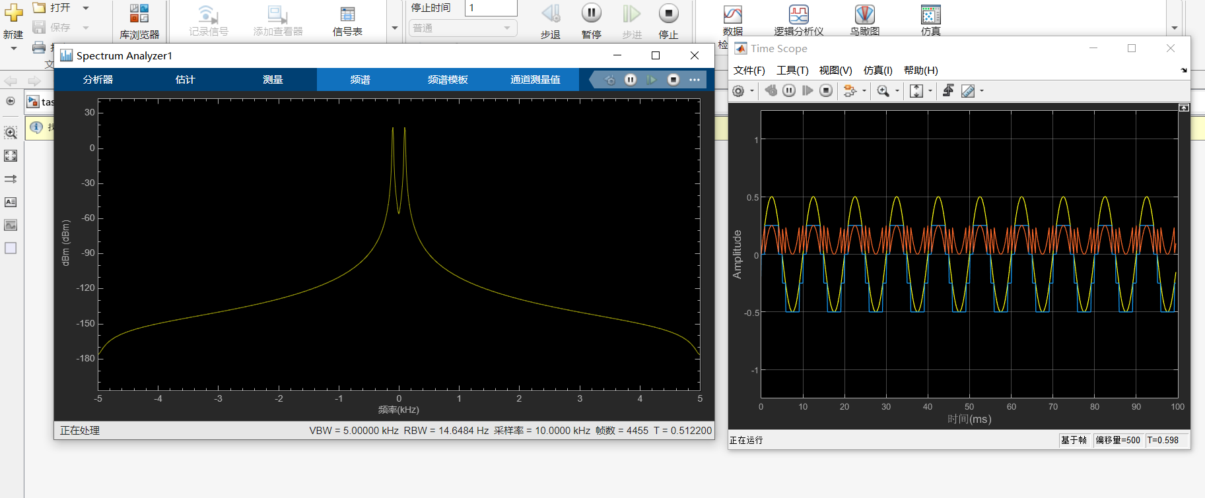

**Exercise 3.**

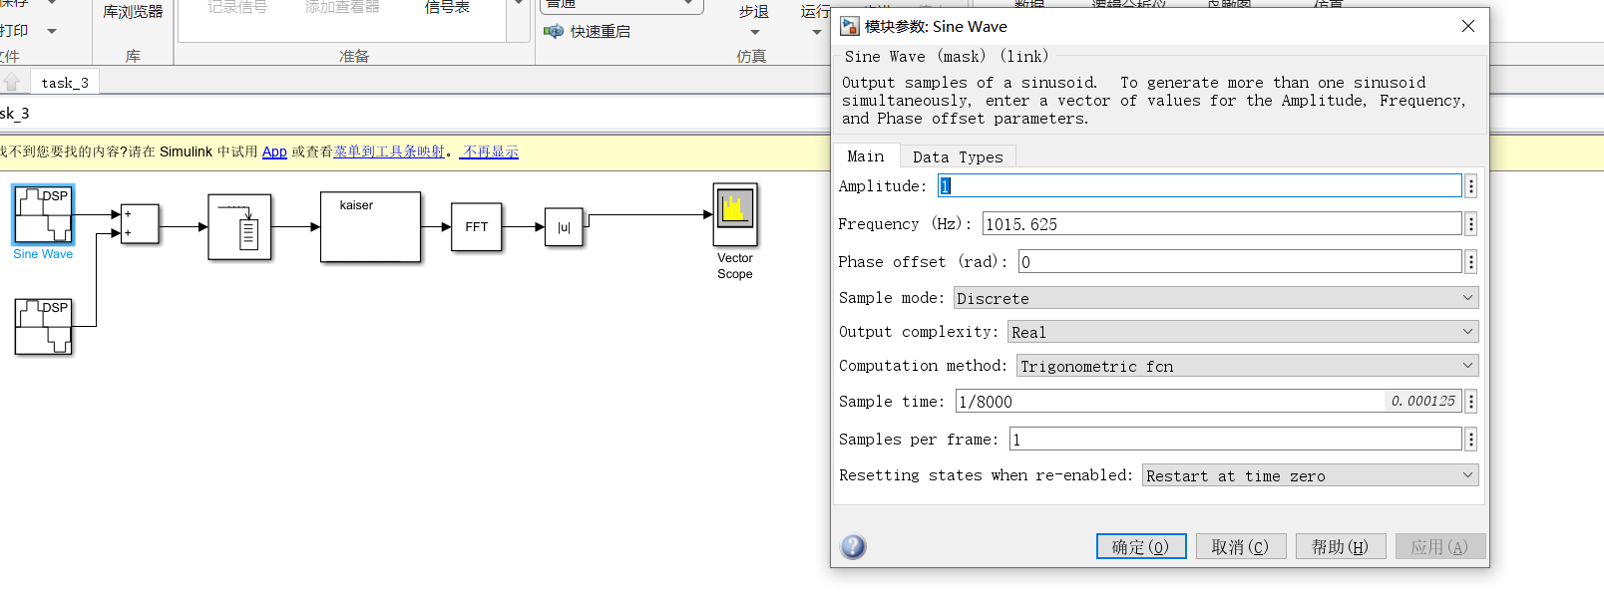

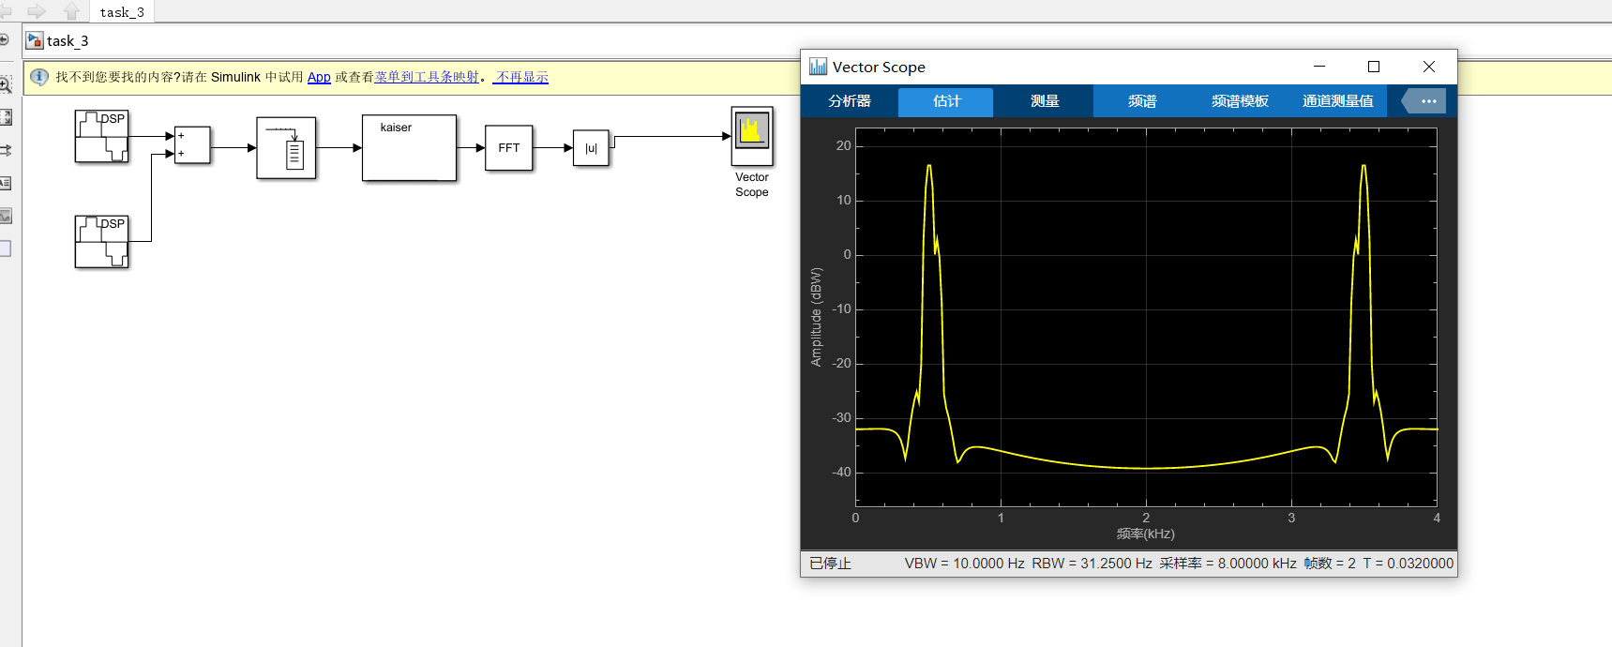

**Control questions**

1. How is a continuous signal converted when input to a digital system?

In digital systems, continuous signals are converted into discrete signals, a process called sampling and quantization. The following is a detailed explanation:

Sampling: continuous signals are sampled at certain time intervals on the time axis. The sampling process discretizes the continuous signal in the time dimension and obtains a series of sampling values at discrete time points. The sampling frequency determines how many samples are taken per second. The commonly used sampling frequencies are 44.1kHz and 48kHz.

Quantization: the amplitude value of the sampled continuous signal is quantized into a series of discrete values. The quantization process discretizes the continuous signal in the amplitude dimension and maps the sampled values to the nearest discrete values. The commonly used quantization bits are 8 bits, 16 bits, 24 bits, etc. The higher the number of bits, the more amplitude levels that can be represented, and the larger the dynamic range of the audio signal.

Coding: after sampling and quantization, a series of discrete sampling values are obtained. These sampled values need to be converted into digital form by coding, which is convenient for storage and processing. Commonly used coding methods include pulse code modulation (PCM) and compression coding (such as MP3 and AAC).

To sum up, continuous signals are converted into digital signals through the processes of sampling, quantization and coding, which is convenient for storage, transmission and processing in digital systems.

2. What is a discrete signal, discrete sequence, digital signal, ideal and natural sampling?

A Discrete Signal is a signal that is discrete in time or space. Its value only exists at a specific time point or spatial position, and it is undefined between these discrete points. Discrete signals can be one-dimensional (such as time series) or multi-dimensional (such as images and videos). Discrete signals are usually represented by mathematical symbols, such as x[n], y[k] and so on.

Discrete Sequence is a special kind of discrete signal, which is discrete in time and discrete in value. Discrete sequences are usually represented by integer indexes, such as x[0], x[1], x[2], etc. Each index corresponds to the value of a discrete point.

Digital Signal refers to a special form of discrete signal, which is usually obtained by sampling, quantizing and coding analog signals. Digital signal is composed of a series of sample points with discrete time and discrete amplitude. Digital signals can be processed, transmitted and stored by digital systems.

Ideal Sampling is a theoretical sampling method, which assumes that the sampling process will not introduce any distortion. Ideal sampling requires that the sampling frequency must be more than twice the highest frequency in the signal to avoid aliasing (that is, spectral overlap). Under ideal sampling, the sampling value of continuous signal is equal to the value of continuous signal at the sampling time.

Natural Sampling is a common sampling method in practice, which uses sampling and holding circuits to obtain discrete samples. In the process of natural sampling, the sampling signal remains unchanged during the sampling interval and is not updated until the next sampling moment. Natural sampling will introduce nonlinear distortion of sample-and-hold circuit, which will lead to the difference between the sampling results and the theoretical ideal sampling.

3. What are the similarities and differences between the spectra of discrete and analog signals?

The spectrum of discrete signal and analog signal has the following similarities and differences:

Similarities:

①　Representing signal characteristics: The frequency spectra of both discrete and analog signals are used to represent the characteristics of signals in frequency domain, that is, the energy distribution of signals at different frequencies.

②　Fourier transform: The frequency spectrum of both discrete and analog signals can be calculated by Fourier transform, which is transformed from time domain to frequency domain.

The difference:

1. Different definitions: the spectrum of discrete signal refers to the representation of discrete signal in frequency domain, while the spectrum of analog signal refers to the energy distribution of analog signal in continuous frequency range.
2. Different representations: the spectrum of discrete signals is usually represented by discrete frequency and amplitude values, while the spectrum of analog signals can be represented by continuous frequency and corresponding amplitude values.
3. Different calculation methods: the spectrum of discrete signals can be calculated by discrete Fourier transform (DFT) or fast Fourier transform (FFT), while the spectrum of analog signals needs to be calculated by continuous Fourier transform (FT).
4. Different resolutions: The spectral resolution of discrete signals is limited by the sampling frequency and the number of sampling points, and usually has discrete frequency components. However, the spectrum resolution of analog signal is relatively high, and it can contain frequency components in a continuous range.
5. Different range: the spectrum range of discrete signals is limited, and the highest frequency is half of the sampling frequency. However, the spectrum range of analog signals is infinite and can contain infinitely high frequency components.
6. Different sampling distortion: Because the discrete signal is obtained by sampling and quantization, aliasing may be introduced in the sampling process, resulting in the difference between the spectrum of the discrete signal and that of the original analog signal.
7. Is it possible to find the spectrum of the original analog signal from the spectrum of a discrete signal?

The spectrum of the original analog signal cannot be completely recovered from the spectrum of the discrete signal. This is because the spectrum of discrete signals is affected by aliasing effect in the sampling process, which leads to the loss of spectral information of some original analog signals. This phenomenon is called sampling distortion.

5. How to determine its spectrum after sampling from the spectrum of an analog signal?

Sampling from the spectrum of an analog signal usually requires the following steps:

① Determination of sampling frequency: Determine the sampling frequency according to the highest frequency component of the signal. According to Nyquist sampling theorem, the sampling frequency should be more than twice the highest frequency component of the original analog signal.

②Sampling: the analog signal is sampled by using the sampling frequency of the analog signal. Sampling refers to collecting analog signals at a certain time interval and recording the sampled values. Sampling can be achieved by an analog-to-digital converter (ADC).

③Obtaining discrete signals: the sampled values will form a discrete sequence, that is, a discrete signal. Each sample value corresponds to the amplitude of the analog signal at a specific time point.

6. What is the effect of aliasing when sampling signals and what results does it lead to?

The influence of aliasing when sampling a signal means that the signal components higher than half of the sampling frequency are mistaken for the signal components lower than half of the sampling frequency, which leads to the appearance of undesirable frequency components in the reconstructed signal. This phenomenon is usually called aliasing.

The aliasing effect will cause the frequency spectrum of the reconstructed signal to change, resulting in undesirable frequency components. These frequency components may mask the true frequency components in the original signal, thus adversely affecting the analysis and processing of the signal. In addition, in digital signal processing, aliasing effect will also lead to wrong filtering results, which makes the digital filter unable to accurately filter out unexpected frequency components.

1. From what conditions is the sampling frequency of analog signals selected?

The sampling frequency selection of analog signals is based on Nyquist sampling theorem. According to Nyquist sampling theorem, in order to accurately recover the original analog signal, the sampling frequency must be at least twice as high as the highest frequency component of the original signal.

Specifically, assuming that the highest frequency component of the analog signal is f_max, the sampling frequency f_s must meet the following conditions:

f_s ≥ 2 * f_max

If the sampling frequency is less than twice the highest frequency component, aliasing effect will occur, which will lead to the inability to accurately restore the spectral characteristics of the original signal.

When selecting the sampling frequency, the highest frequency component in the original signal is generally determined first, and then a sampling frequency greater than or equal to twice the highest frequency is selected. Usually, a certain margin is left to avoid the influence of unpredictable signal spread or noise on the sampling results.

It should be noted that the selection of sampling frequency should also take into account the actual application requirements and system limitations. Too high sampling frequency may increase the calculation and storage overhead, while too low sampling frequency may lead to information loss or aliasing effect. Therefore, the selection of sampling frequency needs to consider the signal characteristics, system requirements and resource constraints.

1. How does the signal spectrum change during sampling?

In the process of sampling, the change of signal spectrum mainly involves spectrum folding and spectrum distortion.

①Spectrum Aliasing: Spectrum aliasing means that the frequency components higher than half of the sampling rate are erroneously restored to the frequency range lower than half of the sampling rate during the sampling process. This is caused by the limitation of sampling theorem. If the signal frequency exceeds half of the sampling rate, the sampling process can not accurately restore the original signal, resulting in spectrum folding.

For example, if the sampling rate is Fs and the signal frequency is f, when f is greater than Fs/2, the frequency f will be wrongly restored to fs-f. This will cause the high-frequency components of the original signal to be aliased into the low-frequency range, causing the distortion of the spectrum.

②Spectrum distortion: Besides spectrum folding, other factors in the sampling process may also cause spectrum distortion. For example, if the sampling rate is too low, high-frequency signals will not be fully sampled, thus losing high-frequency components and narrowing the spectrum. In addition, the selection of sampling window and the characteristics of window function will also affect the accuracy of spectrum.

9. How to reduce distortion due to signal sampling?

In order to reduce the distortion caused by signal sampling, the following measures can be taken:

①Choose a high enough sampling frequency: the sampling theorem shows that the sampling frequency must be higher than twice the highest frequency of the signal to avoid distortion. Therefore, when sampling signals, we should choose a high enough sampling frequency to avoid folding distortion.

②Use low-pass filter: Low-pass filter can remove the high-frequency components folded to baseband interval, thus reducing sampling distortion. Using low-pass filter on the sampled signal can remove folding distortion and high-frequency noise, making the reconstructed signal more accurate.

③Increase the number of quantization bits: the sampled signal needs analog-to-digital conversion to convert continuous analog signals into discrete digital signals. Increasing the number of quantization bits can improve the accuracy of digital signals and reduce quantization errors, thus reducing reconstruction distortion.

⑥Select the appropriate sampling time: sampling time has certain influence on sampling accuracy and sampling distortion. Choosing appropriate sampling time can reduce sampling noise and nonlinear distortion and improve sampling accuracy.

10. Can I use a digital filter to reduce aliasing?

Digital filters can be used to reduce aliasing, including low-pass filters and decimation filters.

When sampling a signal, aliasing is caused by the sampling frequency being less than twice the highest frequency of the signal. In order to eliminate aliasing, a low-pass filter can be used to remove high-frequency components in the signal before sampling, so that its frequency range does not exceed half of the sampling frequency.

In addition, when the oversampling technology is used, it is necessary to downsample the oversampled signal to the normal sampling rate through the decimation filter to avoid aliasing. The decimation filter can choose band-limited filter or polyphase filter to remove aliasing and anti-aliasing distortion.

It should be noted that the choice of digital filter should be weighed according to the signal characteristics. For example, when choosing a low-pass filter, parameters such as signal bandwidth and cutoff frequency need to be considered to avoid error filtering of useful frequency components in the signal. When using the filter, we also need to pay attention to the delay characteristics of the filter to avoid adverse effects on real-time signal processing.